Advanced Games Programming
Tutorial 11 - Orienting Models

Introduction

One thing you must consider when writing a 3D game is to ensure that you orient the models correctly. Imagine for example that an enemy is chasing you - the model representing the enemy will need to be oriented so that it is aligned with its direction of movement, which would normally be towards the camera but might need to be in some other direction if it needs to go round an obstacle to get there.

Orienting a Model

For simplicity the model will only need to be correctly oriented on the xz plane, so there only needs to be a calculation of rotation around the y axis. To orient a model correctly on the xz axis you need to do two things:
- Calculate the angle that the model needs to be rotated by;
- Rotate the model about the y axis by that angle.

Calculating the Model's Rotation Angle

To calculate the angle you first need to define an arbitrary orientation that zero degrees represents. It makes sense to define 0 degrees as facing towards positive z, as you did for the camera. Since you also defined during in the camera tutorial that positive angles represent clockwise rotations, then:
- +90 degrees faces positive x
- +/-180 degrees faces negative z
- -90/+270 degrees faces negative x

Assuming for the moment that the model file faces along positive z by default and you want to orient it towards the camera position, you get this diagram:
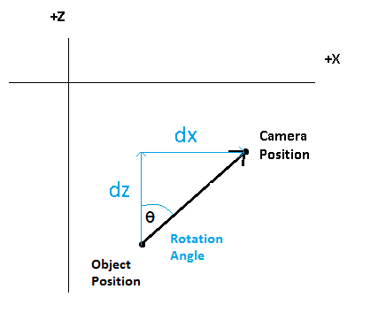
To calculate the required rotation angle θ you can use the standard trigonometry rule:

tan θ = opposite/adjacent

or, in this case, where dz is the difference between the camera z and the model z, and dx is the difference between the camera x and the model x:

tan θ = dx/dz

or

tan θ = (cam.x-object.x)/(cam.z-object.z)

Note that this equation could give a division by zero if dz is 0. To avoid this happening, use the inbuilt arctangent function atan2() e.g.:

m_y_angle = atan2(dx,dz) * (180.0 / XM_PI);

The result of the atan2() function needs to be multiplied by (180.0 / XM_PI) to convert it to degrees (remember pi radians = 180 degrees), and this give the amount to rotate the model around the y axis to face the camera.

You can of course use any point to face towards, the camera position is just useful to demonstrate how an enemy might chase the player. An entity could just as easily be following a pre-set path designated by waypoints, or following another entity.

Rotating the Model about the Y Axis

Having calculated the rotation angle it's then straightforward to rotate the model, if you assume a flat surface represented by the xz-plane. On a flat surface the y coordinate of the model will never change so you can just rotate the model about the y axis, so the front of the object will face towards the designated point. If you didn't create your object with the front facing down positive z, or you chose the wrong axis swap option in the exporter, then you may find the object faces the wrong way. In this case go back and reposition or re-export the object with the correct orientation.

Moving the Model in the Facing Direction

You can move the model in the direction it is facing simply by using yangle (converted to radians by multiplying by (XM_PI/180.0) ) to calculate the x and z offsets required for any given angle, so:

x += sin(m_yangle * (XM_PI/180.0)) * amount;
z += cos(m_yangle * (XM_PI/180.0)) * amount;

where amount is the distance forward you want to move the model. Notice that this works whether m_yangle is calculated by 'looking at' a point or if m_yangle is manually rotated.

Exercise 01 - Orienting and Moving a Model Towards the Camera

- Create a new project based on your Tutorial 10 Exercise 01 project (or one of the extra/advanced exercises), renaming it in the correct way.
- Add three methods to your Camera class, GetX(), GetY() and GetZ() that return the floating point values of those three position elements.
- Add a method to your Model class called LookAt_XZ(). This should:
  - take two floating point parameters that are x and z world space positions that the model should face.
  - calculate dx and dz between the object and the look at position passed in.
  - update m_yangle using the arctangent calculation, don't forget to convert to degrees.
- Add a method to your Model class called MoveForward(). This should take a single floating point value as a parameter that represents a distance, and it should update the model position by using this distance to update the model m_x and m_z positions based on m_yangle, so that the object appears to move in the direction it is facing.
- Assuming you already have a global Model* variable (or add another), create a model and load a .OBJ file that is oriented with its front facing down the z axis into the Model object.
- Remove any transformations that are currently being performed on the model (except scale if needed).
- In RenderFrame() add a call to the model's LookAt_XZ() method, passing in the camera's x and z position.
- Compile the code and move the camera around, check that the front of the model always faces the camera position on the XZ plane. If not go back and check the steps you took to implement the code.
- Next call the model's MoveForward() method, try using 0.001f for starters, you may need to vary this based on how fast your app runs and how big the models are.
- Again compile and check that the program does what is expected, namely the model should move directly towards the camera position at all times.
Hints:
- Set the objects initial position in the InitialiseGraphics() function, immediately after creating and loading it. You could do this for the initial rotation and scale too. If you do this in the render() function, then the position will be reset every frame and the model will not move!!
- Set the models initial rotation to 180.0f (this will make the front face down the +ve z axis). This is only if your model has an obvious front face, as you’ll easily be able to see if the model rotates correctly to face the camera. If you are using the cube or sphere, this process is completely pointless. In this case use the cube to test, set the initial x position to something greater or less than 0.0f. This way you’ll see the flat face of the cube at a slight angle:

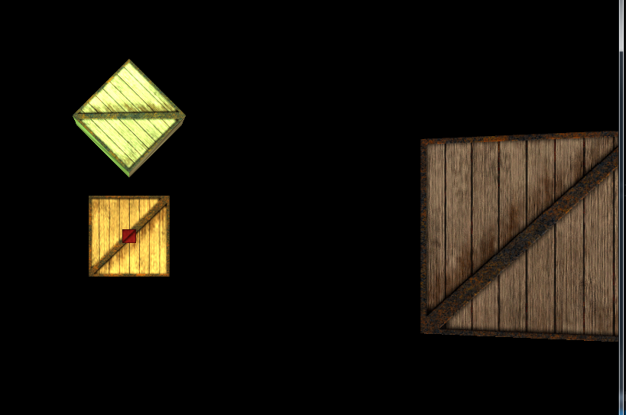
On the left is a cube at 0,0,0. The cube on the right was set to 10.0f on the x axis and is using the lookat and move methods, You can just see the difference in angle on the right cube as it’s facing the camera position. It is also moving towards the camera, so I know that the code is correctly implemented.

Exercise 02 - Orienting and Moving a Model Towards Another Model

- Create a new project based on your Tutorial 11 Exercise 01 project, renaming it in the correct way.
- Add another model to the scene.
- Either automate or add keypresses so that the new model moves around the world.
- Change the first model so that it follows the new model instead of the camera.
- Use this to confirm that the look at and move forward code is working correctly.
- Add more models that follow each other.

